# Te tūhono i a Pōneke ki te ao: Kaupapa here hononga tāwāhi | Connecting Wellington to the world: International Relations Policy

December 2024

## Ihirangi | Contents

Ihirangi | Contents 1

Kupu Whakataki | Introduction 2

Take Kaupapa Here | Policy purpose 2

Ngā hua o te hononga raraupori tāwāhi | Benefits of Civic International Relations 2

Whāinga Kaupapa Here | Policy Objectives 3

Tā Te Kaunihera | The Council’s Role 3

Mātāpono | Principles 4

Kaupapa Here | Policies 4

Ngā whakahaere hononga tāone tuahine | Sister City Relationship Management 4

Te manaaki i ngā taraketi tuarangi | Hosting International Delegations 5

Taraketi reretāwāhi | Outbound Delegations 6

Hapori Whakahangahanga | Diplomatic Community 6

Ngā hononga tāwāhi | International Networks and Connections 7

Kiripānga hononga tāwāhi | International Relations stakeholders 7

Hononga tāone ki te tāone | City-to-city relationships 7

Hunga whaipānga ki Pōneke | Wellington Stakeholders 9

Tākai Here partners 9

Central government agencies and non-government organisations (NGOs) 9

Ministry of Foreign Affairs and Trade (MFAT) 9

Diplomatic missions 9

Local Businesses and Institutions 9

WellingtonNZ 10

International Networks 10

Sister City Associations 10

Te aroturuki me te arotake | Monitoring, Evaluation and Review 10

He kuputaka reo Māori | Glossary 11

## Kupu Whakataki | Introduction

At the centre of Aotearoa New Zealand you’ll find Pōneke Wellington, our creative capital city with a thriving tech, film and innovation scene, flourishing biodiversity, and an increasingly visible partnership with mana whenua.

Pōneke Wellington has much to offer and share with cities across the world. This policy supports Wellington City Council (the Council) to be intentional about where to focus and prioritise international relationships and activities to best take advantage of opportunities overseas.

## Take Kaupapa Here | Policy purpose

To outline how Wellington City Council (the Council) will prioritise our international relationships and activities.

## Ngā hua o te hononga raraupori tāwāhi | Benefits of Civic International Relations

* International relationships are important for cross-cultural understanding and exchange, supporting best practice and knowledge sharing, and creating local, expert-driven economic opportunities.
* City Councils have an important role in making global connections, particularly as Mayors have substantial status and influence, including access to more people and economic opportunities internationally that can support access to business, investment, and trade, as well as cultural relationship building.
* Active international engagement leads to higher visibility and recognition of Pōneke Wellington, raising the profile of our city and helping to improve our reputation and enhance our competitiveness globally.
* Local benefits come from exposing our local communities to different cultures, through sports, arts, education, and cultural exchange. This fosters a deeper understanding and tolerance, ensuring Pōneke Wellington continues to be a welcoming and inclusive city for all.
* As the capital city, Pōneke Wellington has access to further international connections and opportunities through the diplomatic community.
* Mana whenua and hapori Māori set the geographical and cultural context for the region, as a foundational layer to Pōneke Wellington’s mutually beneficial international relationships.

## Whāinga Kaupapa Here | Policy Objectives

The Council’s international relationships seek to connect Pōneke Wellington to the world to support our city vision “Pōneke – the creative capital where people and nature thrive”. Our specific policy objectives are to:

1. Foster global connection and understanding.
2. Facilitate and connect Tākai Here and Te Tiriti o Waitangi partners to the world to achieve their international aspirations.
3. Facilitate and connect local businesses, community, educational and cultural groups to the world to achieve their intended outcomes.
4. Collaborate with cities internationally to learn and share best practices to solve our challenges.

## Tā Te Kaunihera | The Council’s Role

The Council’s core role focuses on four functions – provider, funder, partner and facilitator.

A diagram of the Council's role with each type of role around the outside like a petal. 

The roles of Provider, Funder, Partner and Facilitator are highlighted in blue.

The roles of Regulator and Advocate are not highlighted and are white.

**Kaiwhakarato | Provider -** The Council leads outbound delegations to connect our city leaders, local businesses, educational institutions and community organisations with international opportunities and learning.

**Kaituku Pūtea | Funder –** The Council funds local groups supporting sister city relationships, and cultural events.

**Hoa Patui | Partner –** The Council establishes and maintains city-to-city partnerships, like our Sister City relationships and participation in international networks.

**Takawaenga | Facilitator –** The Council provides the platform for local businesses, embassies, experts and community organisations to connect with relevant international counterparts.

While the Council does not have a role in advocating for national foreign policy, the Council’s international relationships and activities may complement Aotearoa New Zealand’s foreign policy objectives. The New Zealand Government, through the Ministry of Foreign Affairs and Trade (MFAT), is responsible for Aotearoa New Zealand’s national foreign policy on behalf of local and central government. Please see more information about MFAT in the stakeholder table on page 9.

## Mātāpono | Principles

1. International relationships and activities are assessed on their potential to provide mutual benefits.
2. All international relationships must align with the Council’s strategic vision.
3. Decisions on allocating the Council’s limited international relations resources must be made based on how they will contribute to achieving the policy objectives.
4. Focus international relations resources where the Council has a distinct role and opportunity.

## Kaupapa Here | Policies

Wellington City Council engages in international relations activities to connect Pōneke Wellington to the world. The Council agrees international relations priorities every three years to align the international relations work programme with the Council’s strategic priorities.

### Ngā whakahaere hononga tāone tuahine | Sister City Relationship Management

Sister cities are enduring relationships that create numerous, far-reaching and varied opportunities for both cities.

* The Council values and honours the Memorandum of Understanding (MOU) and partnership agreements with our sister and friendly cities. As MOUs come up for review, the Council will ensure the priority areas for our relationships are strategically aligned, relevant and realistic for all partners. ​All future MOUs should be reviewed within 5 years, to ensure that city objectives continue to be active and relevant for all partners.
* The Council facilitates relationship building, understanding and collaboration between our sister cities and Tākai Here partners to enable our partners to create relationships with our sister cities. A similar example is when the Council supported the Botanic Gardens of Wellington to join the tripartite MOU with Singapore Botanic Gardens and National Arboretum of Canberra.
* The Council acts as a facilitator between our sister cities and Wellington communities, including mana whenua, local sporting, art and cultural groups, businesses, education providers and the diplomatic community. ​
* As with other cultural events, we encourage sister city associations, foreign missions, and community groups to conduct their own community events to celebrate Wellington’s Sister and Friendly city relationships. Funding may be available as per our [*Events Policy*](https://wellington.govt.nz/your-council/plans-policies-and-bylaws/policies/events-policy) and the grants process.
* We may provide some specific support to groups organising sister city or cultural events when they align with our sister city MOUs, by connecting organisers to cultural performers from our sister cities or facilitating connections or relationships.

### Te manaaki i ngā taraketi tuarangi | Hosting International Delegations

Wellington City Council extends thoughtful and appropriate hospitality to international delegations that meet the following policy requirements.

* To support successful delegations, all inbound delegation requests received must provide information, including dates and members of the delegation and what outcomes the delegation seeks to achieve (including alignment to any relevant MOUs or agreements). Any requests received with less than two months' notice will only be hosted if they are a mayoral level delegation from a sister city or a priority relationship.
* Delegations need to arrange their own logistics, travel, accommodation, and interpreters (except in specific sister city cases).
* If the Council cannot host the delegation, the Council may connect organisers with other relevant community groups, businesses and organisations, mana whenua, or embassies.​ Elected members will not use Council resources to make their own arrangements to host international delegations without endorsement from the Mayor.
* Mana whenua will be offered the opportunity to be involved in inbound delegations that align with their priorities.​

### Taraketi reretāwāhi | Outbound Delegations

Outbound delegations offer opportunities for mana whenua, businesses, education providers, art, sporting and cultural groups, and experts to connect, learn and develop ongoing relationships with international cities and partners.

* Outbound delegations are planned as part of the triennium priority setting and annual planning process. Outbound delegation planning considers Pōneke Wellington’s strategic priorities and partners’ priorities for planned visits, appropriate study delegations to support the Council delivering on these priorities, and any key global network events and sister city anniversaries. ​This ensures outbound delegations are communicated to potential delegates at least 6 months in advance to allow appropriate planning and involvement.
* Wellington City Council’s Terms of Reference stipulate the approval processes for overseas travel of elected members.
* Tākai Here partners will be offered the opportunity to be involved in all outbound delegations that align with their international relations priorities.

### Hapori Whakahangahanga | Diplomatic Community

As the capital city of Aotearoa New Zealand, the Council values our relationships with the diplomatic community, including Embassies, High Commissions, Consulates, and Honorary Consuls in Pōneke Wellington.

* The Mayor’s Office hosts diplomats at an annual event, where mana whenua are invited to contribute and participate.
* The Mayor meets with newly appointed heads of mission and the Mayor, elected members and staff attend embassy and diplomatic events on a case-by-case basis.
* The Council prioritises relationships with our diplomatic community that align with the strategic priorities identified for the triennium.
* The Council facilitates relationships between the diplomatic community and other key stakeholders, including mana whenua, internal Council teams, and with our sister cities and other international communities. ​
* The Council is unable to significantly contribute to the organising of national cultural events put forward by embassies unless there is strong strategic alignment with the Council's priorities and benefit for Wellington communities.​

### Ngā hononga tāwāhi | International Networks and Connections

International networks and connections support relationship building, business networks, and learning and sharing.

* The Council collaborates and seeks opportunities for joining relevant international networks or building short-term purpose-based relationships with other city authorities.
* Membership of international networks is evaluated every three years to consider if the membership is adding benefit for Pōneke Wellington.

## Kiripānga hononga tāwāhi | International Relations stakeholders

### Hononga tāone ki te tāone | City-to-city relationships

Over time several formal relationships have been formed between Wellington and cities primarily in the Asia-Pacific region. These have been established primarily through an economic lens with some cultural benefits. The relationships are two-way partnerships and involve the cities responding to requests for information and support from one another.

Wellington has several city-to-city relationships dating back many years. This table defines the types of relationships we hold and the cities we hold them with.

**Sister city**: a formal, long-term relationship based on diverse linkages between two cities which includes cultural, educational and business connections. Sister city relationships require a high degree of commitment on both sides, and active involvement of local communities.

**Sister cities:** Beijing, China; Xiamen, China; Sakai, Japan; Sydney, Australia; Canberra, Australia; Seoul, South Korea.

**Historical sister city:** a relationship based on historic ties, often dating back to an event in history that has significant meaning for both cities. Historical sister cities are not formalised in the same way as a standard sister city but will often co-operate in commemorative projects and cultural exchanges.

**Historical sister cities:** Chania, Crete; Harrogate, England; Çanakkale, Türkiye.

**Friendly city:** a less formal and lower profile relationship than a sister city. It is likely to be a long-term relationship but the level of community involvement and required support is not as high as seen with a full sister city relationship.

**Friendly cities:** Tianjin, China; Ramallah, Palestine[1]

**Partner city:** a time-bound relationship focused on a specific initiative in which the cities share an interest.

**Partner city:** Taipei, Taiwan.

**Memoranda of co-operation:** an agreement to foster economic, best practise and cultural opportunities.

**Cities with a memoranda of co-operation:** Zhejiang Province, China (in partnership with Hutt City, Porirua City and Kāpiti District councils); Tripartite MOU with Singapore Botanic Gardens, Botanic Gardens of Wellington and National Arboretum of Canberra; Hanoi, Vietnam.

**Wellington City Council’s existing sister, historical sister, friendly and partner cities.**

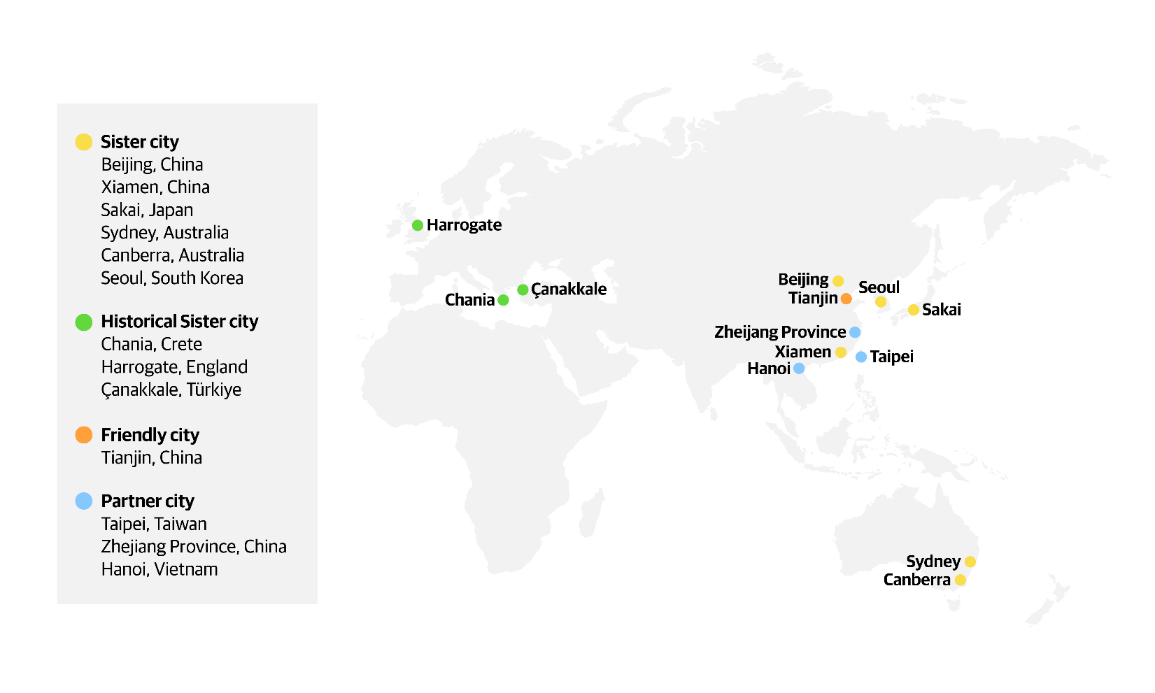

### Hunga whaipānga ki Pōneke | Wellington Stakeholders

#### **Tākai Here partners**

Our Tākai Here partnership agreement is with Taranaki Whānui, Te Ati Awa, Ngati Toa and Wellington City Council.

**Role in the Council’s International Relations:** The Tākai Here partnership agreement established a shared commitment to partnership along with shared values and tikanga. The partnership agreement underpins how we work with Tākai Here partners internationally.

#### **Central government agencies and non-government organisations (NGOs)**

Some government agencies and non-government organisations are dedicated to connecting internationally for specific purposes, for example Asia New Zealand Foundation and Education New Zealand.

**Role in the Council's International Relations:** The Council collaborates with these groups to support Wellington based groups to connect with their sector internationally.

#### **Ministry of Foreign Affairs and Trade (MFAT)**

MFAT is the New Zealand Government’s principal agent for pursuing the country’s foreign policy interests and representing New Zealand offshore. It pursues the New Zealand Government’s international priorities and provides advice to the Government on the implications for New Zealand of what is happening in the world.

**Role in the Council's International Relations:** MFAT is able to inform the Council of the New Zealand Government’s foreign policy interests and priorities. This information may assist the Council with its international relationships and activities that may, in turn, complement the Government’s foreign policy objectives.

#### **Diplomatic missions**

The role of embassies and high commissions is to promote the interests of their nation and develop their nation’s relationship with Aotearoa New Zealand.

**Role in the Council's International Relations:** The Council hosts and attends events involving the 50 diplomatic missions based in Wellington. Working with the diplomatic community provides an opportunity to connect directly into other nation’s policies, knowledge economy, and the opportunities available for Wellington and respective regions within these nations.

#### **Local Businesses and Institutions**

Wellington-based small to medium sized businesses and educational, sporting and cultural institutions.

**Role in the Council's International Relations:** The Council provides business and industry representatives with opportunities to participate in inbound and outbound delegations and city-to-city business initiative and relationship building opportunities.

#### **WellingtonNZ**

WellingtonNZis a Council Controlled Organisation (CCO) in the Wellington Region.Therole of WellingtonNZ is to attract visitors, businesses, investment, and events to Wellington. Their focus is on supporting businesses to grow, innovate and meet the future workforce needs, enhance Wellington’s reputation for creativity, and work collaboratively to encourage investment in the region.

**Role in the Council's International Relations:** The Council works with WellingtonNZ to identify local business institutions to be involved in outbound delegations and other opportunities with international partners. At times WellingtonNZ supports the Council with hosting inbound delegations or diplomats. WellingtonNZ supports the Council to gather data on the impact of delegations.

#### **International Networks**

These networks provide opportunities to promote Wellington, share knowledge, combine efforts to resolve common problems, and learn about best practice.

**Role in the Council's International Relations:** The Council and its CCOs are members of several international networks. These relationships are industry and business unit-focused and are generally informal, time-bound, and may not require ongoing relationships or commitments.

#### **Sister City Associations**

These groups operate independently from the Council with the purpose of supporting sister city relationships by sharing, educating, and facilitating community initiatives.

**Role in the Council's International Relations:** These associations are a requirement of some sister city relationships and support the Council to maintain the relationship and to ensure the community connection to the sister city relationship. The Council provides these associations with annual grants, depending on events and activities planned for the year.

## Te aroturuki me te arotake | Monitoring, Evaluation and Review

The monitoring and evaluation of this policy includes documenting the participation, quality of experiences and long-term outcomes of stakeholders. This will inform the international relations priority setting for the next triennium.

The International Relations Policy will be reviewed as required, at least once every 5 to 10 years.

## He kuputaka reo Māori | Glossary

**Pōneke:** The word Pōneke is used in the policy as the translation of Wellington city to refer to the Wellington City Council boundaries and to align with Wellington City Council’s vision.

**Mana whenua:** Territorial rights, power from the land, authority over land or territory, jurisdiction over land or territory - power associated with possession and occupation of tribal land.

**hapori Māori:** Māori communities

1. Wellington City Council is connecting with Ramallah to explore the possibility of formalising the relationship to that of a friendly city. At the time of writing this policy, the relationship has not been formalised in a signed agreement.