Kia ora! This guide will help you prepare for the Matariki Ahi Kā event held at Wellington's Waterfront. It covers what the event is like, what to bring, and what you can expect.

We’re excited to welcome you and hope you enjoy your time with us.

## What am I allowed to bring?

You can bring comfort items like headphones, fidget toys, or earplugs. These items can be particularly helpful if you feel overwhelmed by busy or sensory-heavy environments.



## What should I bring?

Matariki Ahi Kā takes place in the middle of winter, so we recommend bringing warm clothes, windproof jackets, scarves or beanies, and possibly gloves. It’s also a good idea to wear comfortable shoes for walking around.

You can bring a water bottle or light snacks. Food will also be available at the event.

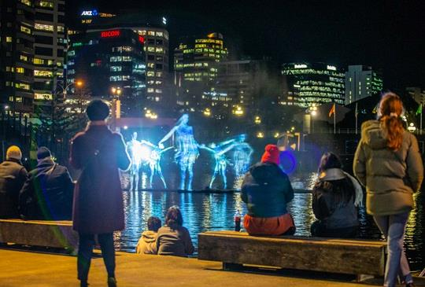

## Where can I get food and how do I pay?

There will be two food courts at Matariki Ahi Kā full of food trucks selling many different types of food and drink.

One will be in Odlins Plaza, the other at the back of Te Papa. Most food trucks accept debit or credit card, but it can be a good idea to bring cash just in case.

Each food court will have picnic tables you can sit at to eat your food, but you are welcome to continue roaming with your food. You are also free to bring your own food into the event from any other restaurant or from home, or you can eat before you arrive.    
  
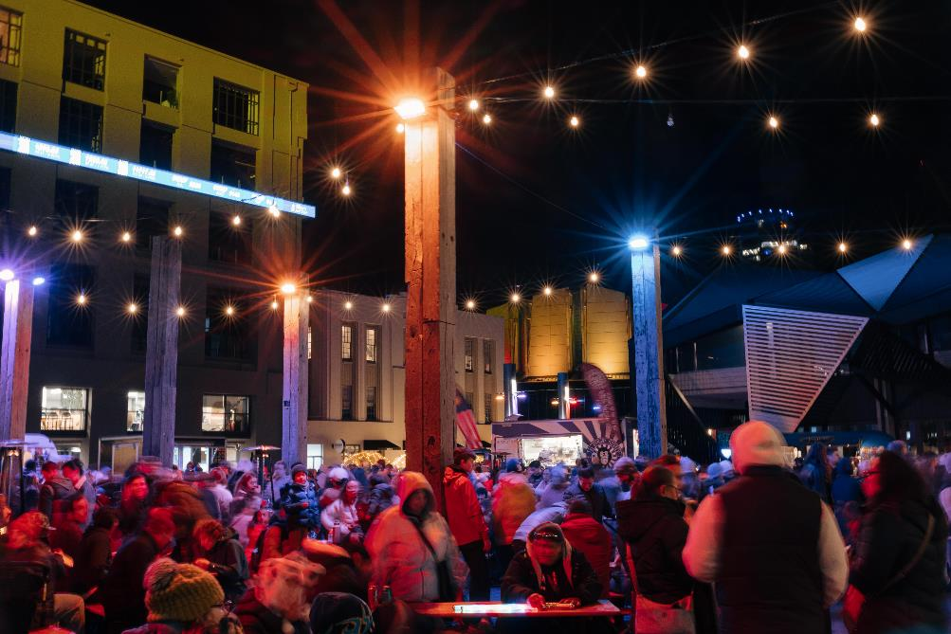

## How do I get there?

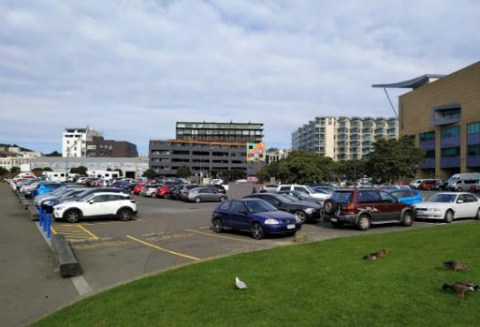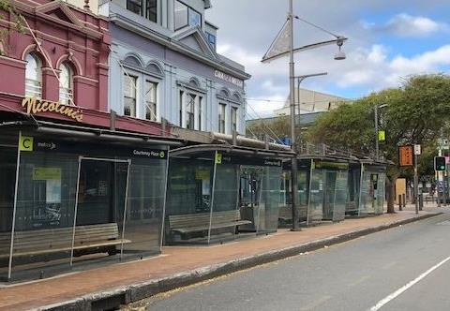Matariki Ahi Kā takes place along Wellington’s Waterfront. There's no direct bus stop at the waterfront, but Courtenay Place is approximately 400 meters away and connects to numerous bus routes.   
  
Paid parking is available nearby at Barnett Street Carpark and Te Papa Carpark, with Wellington City Council parking becoming free after 8pm. There are also drop-off zones around the waterfront perimeter.

## What will the experience be like?

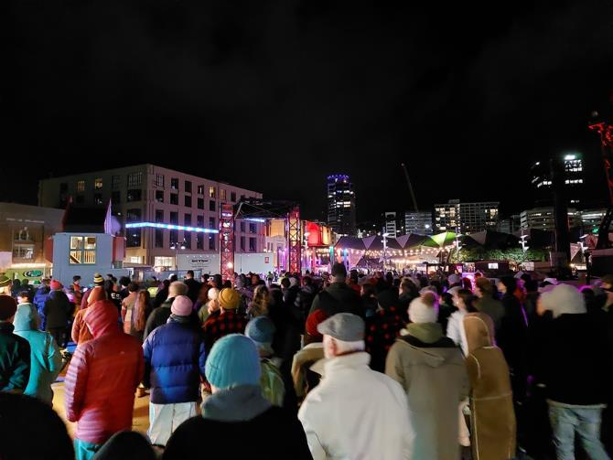Matariki is a time to reflect, connect, and come together. This event runs from 6pm to 9pm for four evenings over the Matariki public holiday week and is free and open to everyone. The dates change slightly each year, so visit our website to keep up to date.

This event is an immersive experience and you’ll be free to move at your own pace through a series of installations, performances, and interactive zones. The environment is full of both visual and audio sensory experiences. Expect art installations that are vibrant, bold, with lots of light and sound.   
   
You can expect to see live music performances on stages near each food court, large projections on buildings like Te Papa and The Boatshed, fire pits where you can sit, warm yourself and have some quiet time, a ceremony each night honouring those who have passed away and places to share kai with friends and whānau.

You can start wherever you like and move through the space however suits you. It’s a choose-your-own-adventure kind of evening.

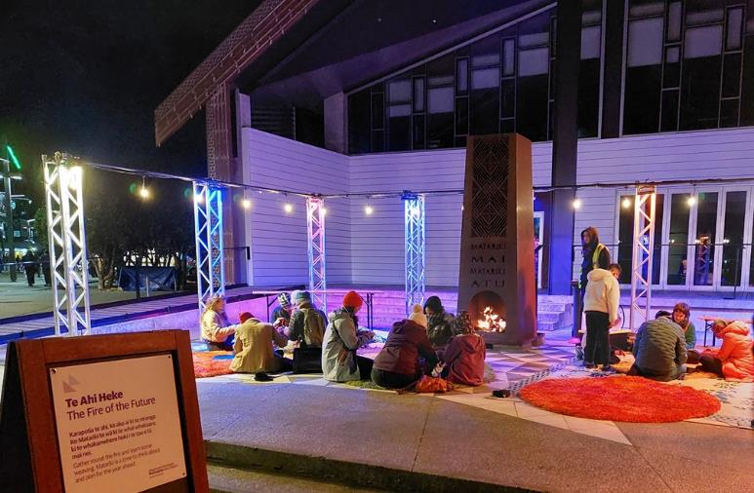

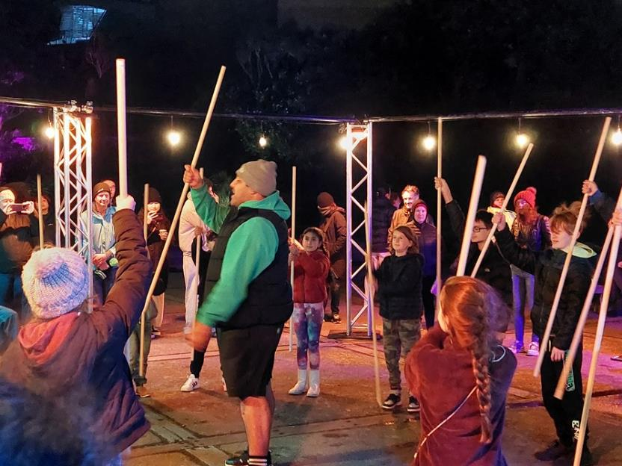

## Are there quiet spaces available?

Matariki is a popular event and can attract large crowds, however the waterfront offers plenty of quiet areas, both inside and outside the event zone. There are always spaces with less people and less noise, some of which are listed below:

There's a contemplation space near Solace in the Wind (the statue of the naked man) where you can sit by a fire and look out to the water.

At Frank Kitts Park, located just outside the main event area, there is a peaceful space with trees and fewer people.

Our information site between Odlin’s Plaza and Circa Theatre is also a safe space you can head to if you are feeling overwhelmed. A friendly staff member will be there each night to answer any questions you have and help however you need.

Feel free to take a break from the event whenever you need to — and come back when you’re ready.

## Image of the fire brazier at the contemplation zone. A crew member is stoking the fore while a group in the background sits close-by, looking comfortable and warm. Who can assist me if I need help?

Event staff will be wearing orange hi-vis vests with “Creative Capital City Events” written on the back. They’re there to help you — feel free to approach them with any questions or if you need support.

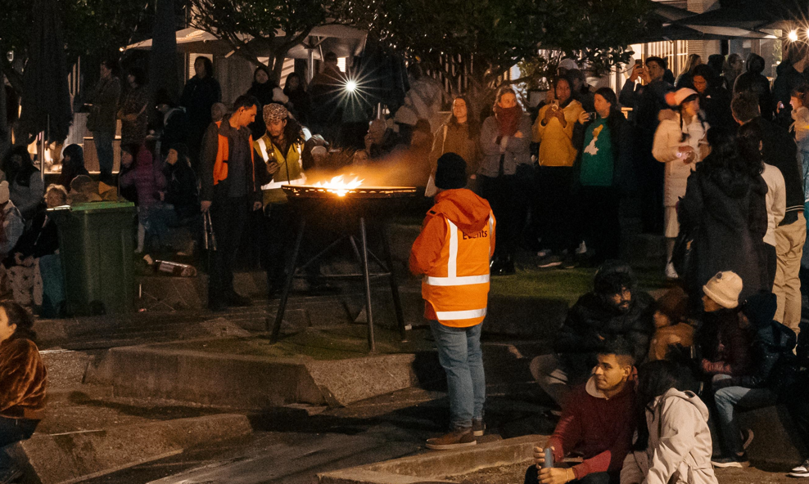The event happens over a large space, so specific places on the map can be hard to find. Event crew on the night will be more than happy to help you find any places listed in this video or on the map when you arrive.  Please do ask them for directions if you need them.

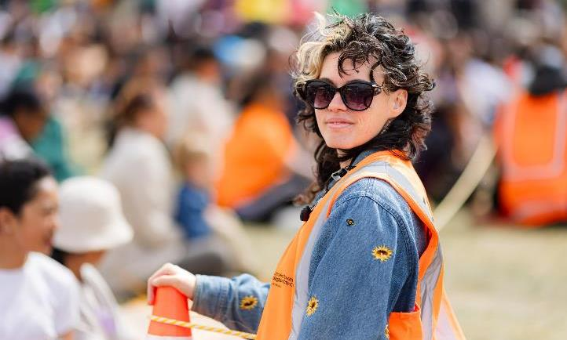You’ll also find signs across the event site showing where things are, including toilets, exits, quiet areas, and activities.

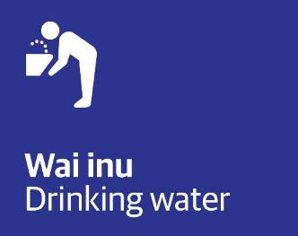 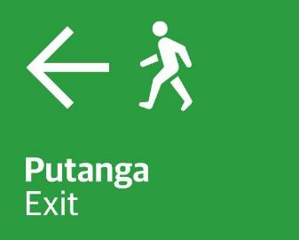 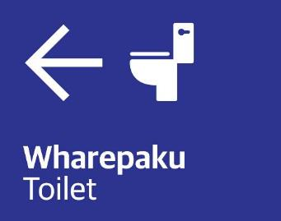

## Where are the toilets and how do I access them?

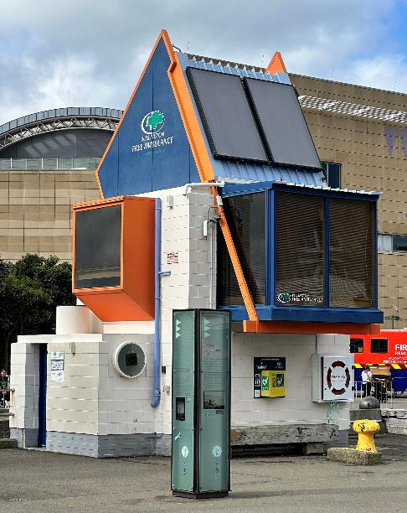Toilets are located at several places across the event.

There is an accessible toilet at the Linkspan building, which is behind the Information Site.

There’s a toilet truck near the Kai Court at Odlin’s Plaza. This looks like a big, white truck trailer with doors in the side. These doors lead to toilet stalls. You will have to climb about 5 steps to access these toilets. There are handrails on the steps.

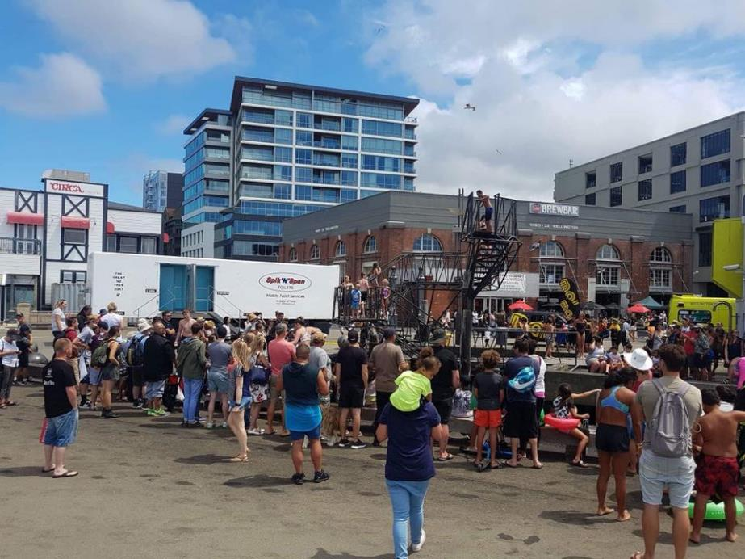You can also find permanent public toilets (including accessible toilets) along the promenade between Whairepo Lagoon and Frank Kitts Park, and Portaloos will be located behind Te Papa. The toilets will be open all evening. Portaloos lock from the inside and most have hand sanitiser instead of running water.

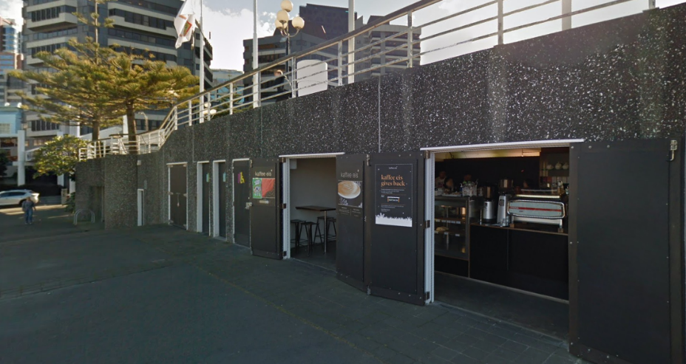

We hope this guide helps you prepare to attend Matariki Ahi Kā. If you have more questions, you can [email the events team](mailto:events@wcc.govt.nz?subject=Matariki%20Ahi%20Kā) for more information or visit the [event page on our website](https://wellington.govt.nz/news-and-events/events-and-festivals/matariki).

We’re looking forward to seeing you at Matariki Ahi Kā!