# What to expect at ANZAC Day

Kia ora! This guide is to help you prepare for ANZAC Day commemorations in Wellington. It will cover what the day looks like, what you should bring, and what you can expect when you attend.

More specifically, this guide will cover the ANZAC Day Civic Wreath-Laying Ceremony, held at the Cenotaph Precinct (on the corner of Lambton Quay and Bowen Street, central Wellington). The event is free and does not require tickets.

We hope this guide helps you feel comfortable and confident to come along.

## A group of army representatives in military uniforms.

## What is the experience like?

The Civic Wreath-Laying Ceremony begins at 9:00 AM, but the band will start playing around 8:30 AM. You are welcome to arrive from 8:00 AM onwards.

When you arrive, you may see a line of people holding wreaths near the Parliament gates. You are welcome to move past them and find a place to stand or sit.

The service includes:

* A welcome from a reverend
* Wreath laying at the Cenotaph
* Live band music
* Speeches
* A minute of silence
* The New Zealand and Australian national anthems

Each part will be introduced by the reverend, so you know what’s happening. You may also see military personnel in uniform.

There won’t be a gun salute this year, but there may still be loud sounds from the speakers. Feel free to bring earplugs or other items that help you feel comfortable.

## What am I allowed to bring?

When you come to the ANZAC Day Commemorations, you can bring headphones, fidget toys, headphones, blankets and any other items that help you feel comfortable.



## What should I bring?

This is an outdoor event in the early morning, so we recommend:

* A warm jacket or scarf
* A water bottle
* A seat or cushion (especially if you’d like to sit)

Weather in Wellington can be unpredictable, so layers are a good idea.

## Where is the event?

The ceremony takes place at the Cenotaph Precinct, located at the corner of Lambton Quay and Bowen Street in Wellington.

## How do I get there?

* Bus: Wellington Station bus hub is about 200m from the Cenotaph
* Train: Wellington Station is a 5-minute walk

Visit the [Metlink website](https://www.metlink.org.nz/) for the latest travel info

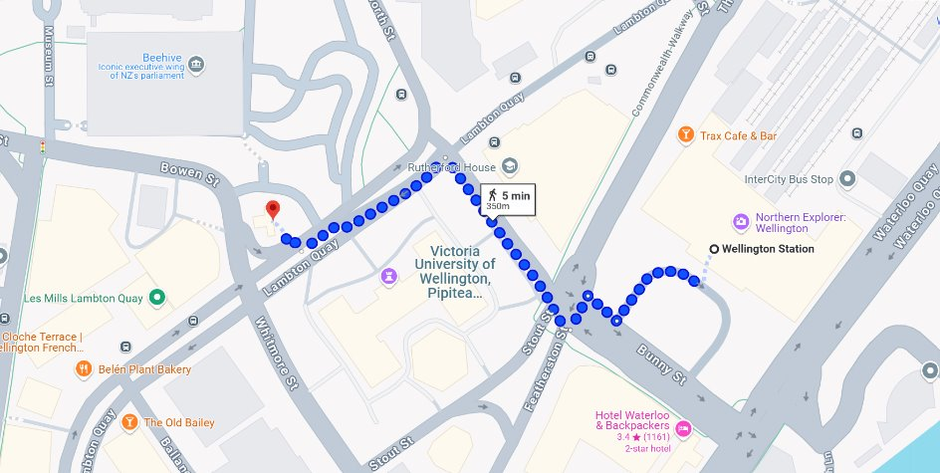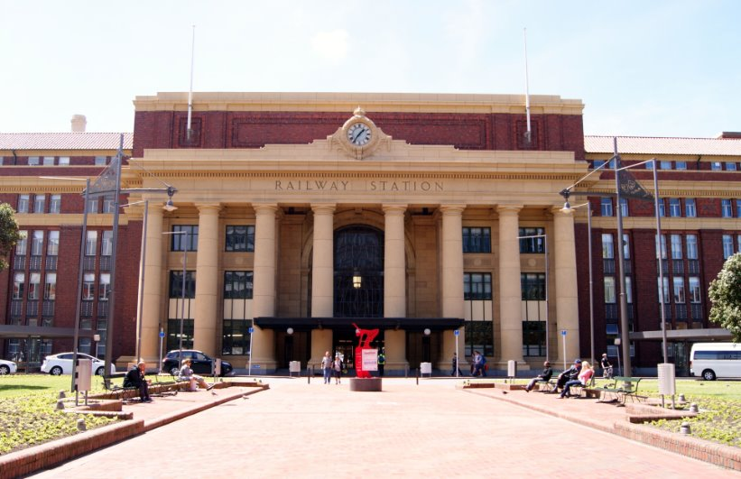   
*Imagery ©2025, Map data ©2025 Google*

## Driving, being dropped off, or cycling?

* Car parks are available on Molesworth Street and Lambton Quay
* Parking is free on public holidays
* For drop-offs: Molesworth Street has a drop-off point
* The Parliament Park drop-off zone is reserved for wreath layers
* Bike parking is available on Molesworth Street and Lambton Quay. Please don’t park bikes near the Cenotaph.

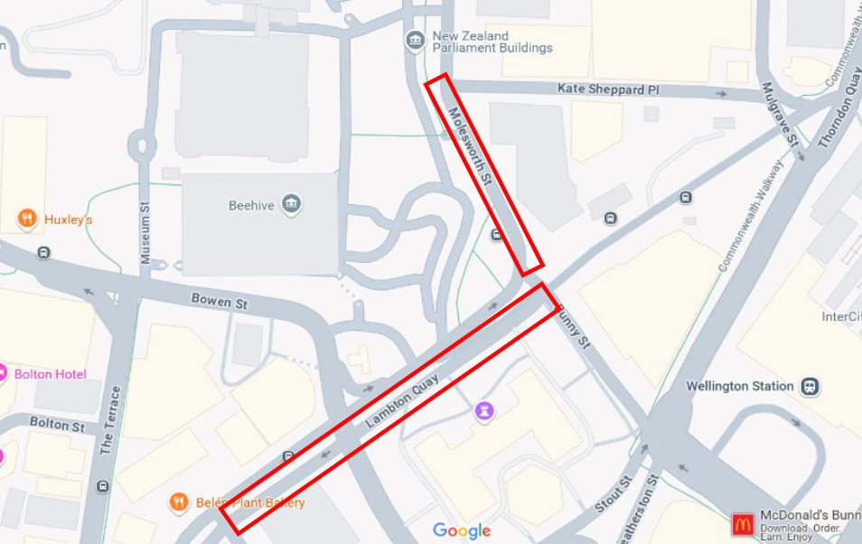   
*Imagery ©2025, Map data ©2025 Google*

## Can I get food and how do I pay?

There won’t be food stalls at the event, but local cafés and eateries nearby may be open.

Many people eat before or after the event. If you do need to eat during the event, we recommend moving back toward the Parliament gates to avoid disruption.

## Are there quiet spaces I can go to?

The Parliament lawn and park nearby offers a quieter space if you need a break.

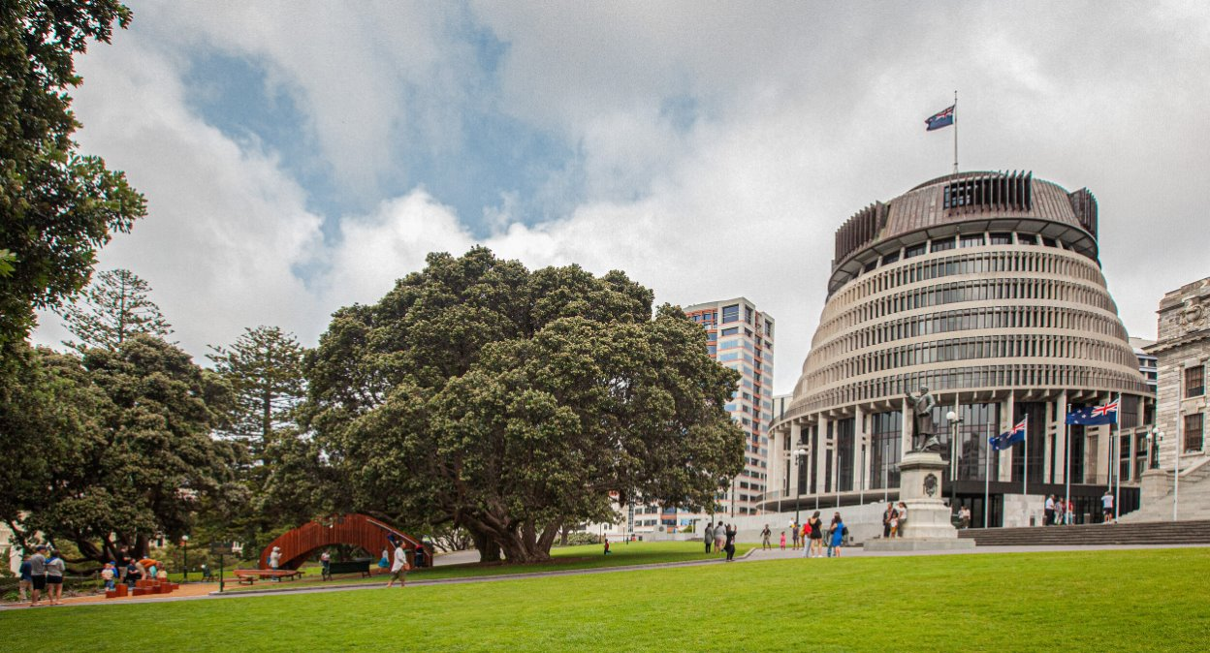You are welcome to leave the event and return if you need to take time away. Event staff can help guide you to quieter areas.

## Who can assist me if I need help?

Event staff are here to help you. You’ll see them in orange high-vis vests that say “Creative Capital City Events” on the back.

**You can:**

* Approach them at any time for help
* Ask them where to find toilets, exits, or quieter spaces



There will also be signs at each event to let you know where things like exits and entries, toilets and other activities are. Keep an eye out for them and ask a crew member in hi-vis if you get lost!

A sign directing you to the exit. It has a green background, an icon of a person walking, an arrow pointing to the exit and the following text, which is Māori and English: “Putanga – Exit”


## Where are the toilets and how do I access them?

There will be **portaloos available**, including an **accessible portaloo**. These will be located on Lambton Quay, near the Parliament Lawn.

* These toilets will be bright yellow like the one pictured to the left
* These toilets are available for use at any time
* They **lock from the inside**
* Most include **hand sanitiser** instead of running water
* The image below shows you where you can find them on Lambton Quay – they are represented by the red rectangles.

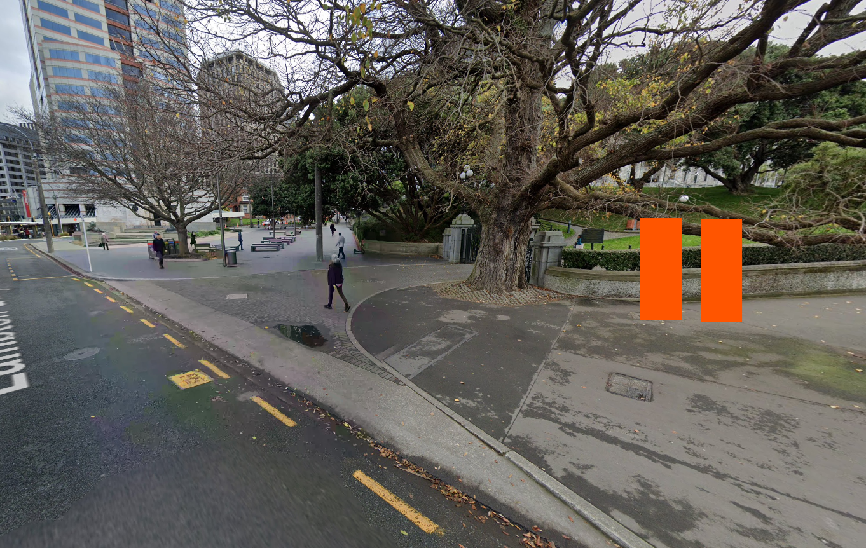

We hope this guide has been helpful and we look forward to seeing you at **ANZAC Day 2025**.

If you have any questions, you can:

* Email the events team at **events@wcc.govt.nz**
* Visit our [website](https://wellington.govt.nz/news-and-events/events-and-festivals/anzac-day) for more information

Ngā mihi nui, we hope you have a meaningful and peaceful experience.